# Introduction to Big Data

**Learning Objectives**

* Define what Big Data is and identify key Big Data characteristics.
* Provide examples of Big Data related technologies, describe the impact of Big Data on businesses and people, and define the relationship between the Internet of Things (IoT) and Big Data.
* Compare linear to parallel processing and explain why Big Data requires parallel processing.
* Describe scalability, including horizontal scaling, embarrassing parallel calculations, and fault tolerance as they relate to Big Data.
* List the key Big Data ecosystem tooling categories and their associated major tools and vendors.
* Explain the role of open-source in Big Data and list related platforms and open-source frameworks.
* Describe the key sources and different types of Big Data.
* Provide examples of real-world Big Data use cases.

Introduction:

The latest statistics report that the accumulated world’s data will grow from 4.4 zettabytes to 44 zettabytes, with much of that data classified as Big Data. Revenues based on Big Data analytics are projected to increase to $103 billion by 2027. Understandably, organizations across industries want to harness the competitive advantages of Big Data analytics. This course provides us with the foundational knowledge and hands-on lab experience we need to understand what Big Data is and learn how organizations use Apache Hadoop, Apache Spark, including Apache Spark SQL, and Kubernetes to expedite and optimize Big Data processing.

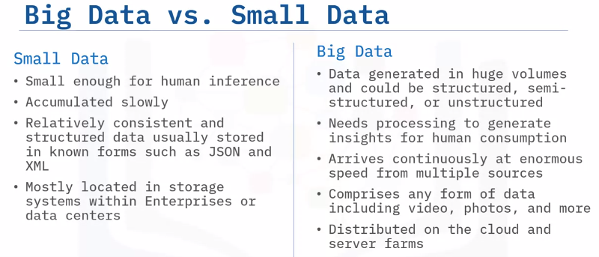

It is a common misconception that Big Data refers to just large volumes of data. In reality, Big Data is the entire life cycle of working with large volumes of data. Let’s take a look at each phase in the Big Data life cycle. Big Data collection is initiated as a result of a business problem or requirement. As data is collected, it gets stored using a framework for distributed storage such as Hadoop HDFS.

To make sense of all the data collected, Map and Reduce tasks and scripts create a data model to store it in a database. This data model includes the various data entities (or objects), and the relationship and rules between these entities. After modeling, data is ready to be processed. Tools such as Apache Spark are used to produce meaningful information from the modeled data. Finally, the processed data is visualized and presented in a graphical format such as charts and graphs. This visualized data is then used for making meaningful business decisions and lead to new business cases, thereby creating a continuous life cycle.

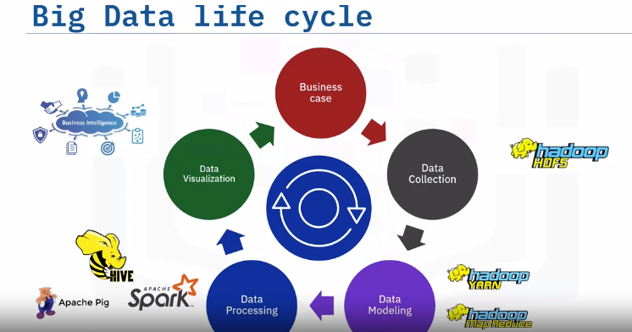

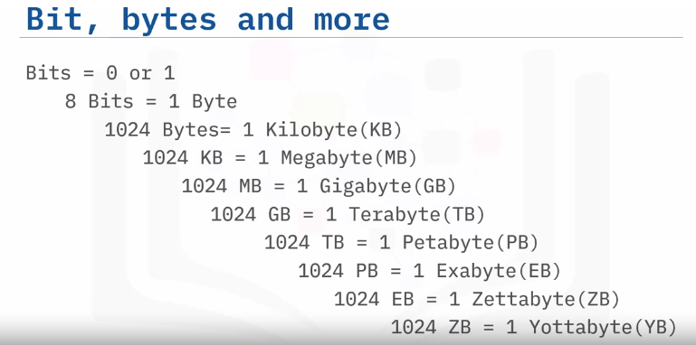

# Four V’s:

When we talk about Big Data, we traditionally talk about the four V’s of Big Data. These are: Velocity, Volume, Variety, and Veracity. Velocity is the speed at which data arrives. Volume is the increase in the amount of data stored over time. Variety is the diversity of data. Many forms of data exist and need to be stored. Veracity is the certainty of data. With a large amount of data available, how will we know if the data collected is accurate or inaccurate? These four main components are used to describe the dimensions of Big Data.

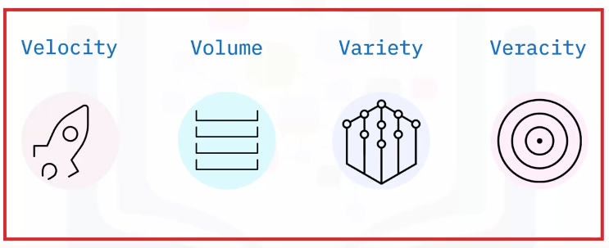

## Velocity:

Velocity signifies that data is being generated extremely fast, and the process never stops. Data must be processed quickly so that decisions can be made at the speed with which the data arrives. Velocity’s main attributes are: batch close to real-time, and streaming. What are the drivers? Definitely improving connectivity and hardware. Just think about all the devices that are connected through the Internet today and all the super-fast response times. Big Data also supports upscaling of pre-calculated analysis.

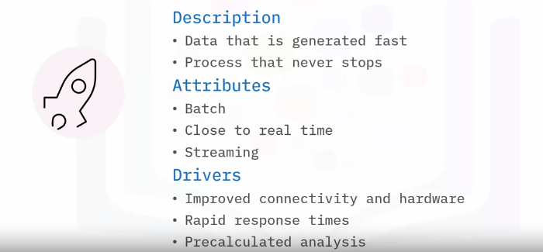

## Volume:

Volume is the increase in the amount of data stored. The amount of Big Data generated is vast compared to traditional data sources. Volume attributes of Big Data are: Petabytes, Exa, and Zetta, to name just a few. Typical drivers of volume in Big Data are: the increase in data sources, higher resolution sensors, and scalable hardware infrastructure.

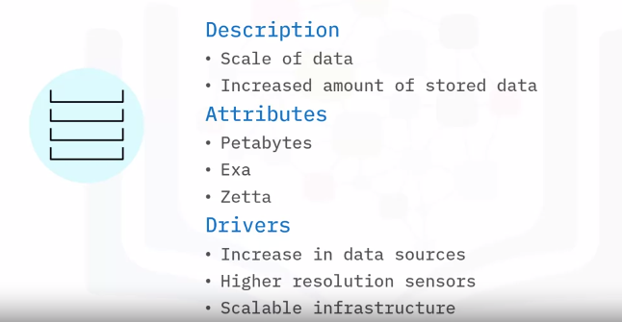

## Variety:

Variety is the diversity of the data. Data is generated by people and processes through the use of machines, from both inside and outside an organization. Some of the data is structured and semi-structured, but most is unstructured. The main attributes are structure, complexity, and origin. Drivers of Variety in Big Data can be: mobile technologies, scalable hardware infrastructure, resilience, fault recovery, and efficient storage and retrieval.

## Veracity:

Veracity is the quality, origin, and conformity to facts and accuracy of the data. This is because data comes from both within and outside an organization. Attributes include consistency and completeness, integrity, and ambiguity. Drivers of Veracity in Big Data are: cost and the need for traceability, robust ingestion, and extract, transform, load (ETL) mechanisms.

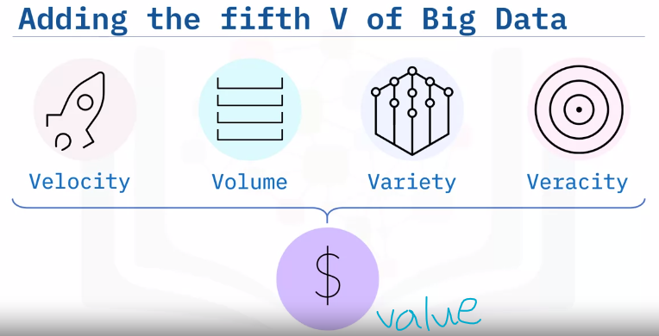

Big Data has another V that must be considered. The fifth V of Big Data is Value. It is the outcome of making intelligent business decisions from leveraging the previous four V’s. The ultimate goal of an organization is to: produce value in the form of faster and smarter business decisions, increase efficient use of resources, and discover of new market opportunities. Big Data supports innovation and thus creates value.

**Summary:**

Big Data is the digital trace that gets generated in this digital era. Big Data is a high-volume, high-velocity, and/or high-variety information asset that demands cost-effective and innovative tools for processing. The core features of Big Data are the 4 V’s: Velocity, Volume, Variety, and Veracity. Big Data creates a fifth V, Value, when collected, stored, and processed correctly.

# Impact of Big Data:

## Learning Objectives:

* List examples of Big Data related technologies
* Explain the impact of Big Data on businesses and people
* Describe the Internet of Things (IoT) and its impact on Big Data

## Generating and using Big Data:

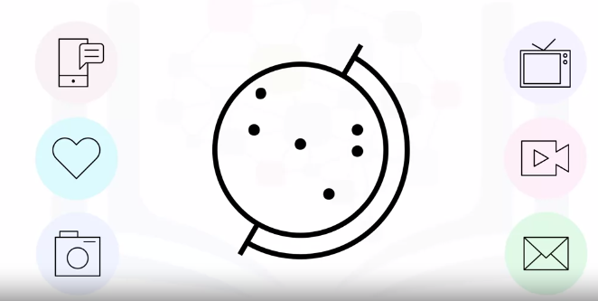

Big Data is one of the most important subjects of this century. Yet globally, millions of people are generating and using Big Data without necessarily being aware of it. This personal data in the form of photos, videos, and text that people send to each other forms the bulk of data collected by consumer goods companies. So, it is interesting to consider how Big Data is impacting businesses and people.

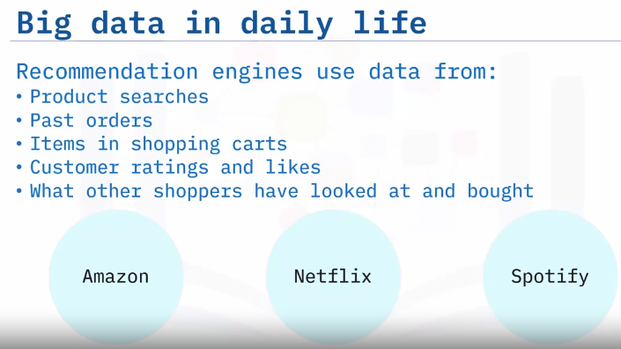

Have you ever searched for or bought a product on Amazon? Did you notice that Amazon’s recommendations are based on what the users have searched for, have bought in the past, the items they have in the virtual shopping cart, items they have rated and liked, and what other customers have viewed and purchased. Companies like Amazon, Netflix and Spotify use algorithms based on big data to make specific recommendations based on customer preferences and historical behavior.

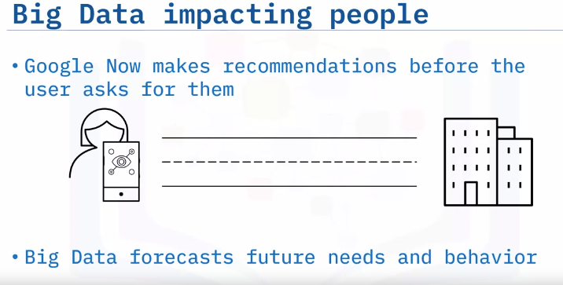

## IoT:

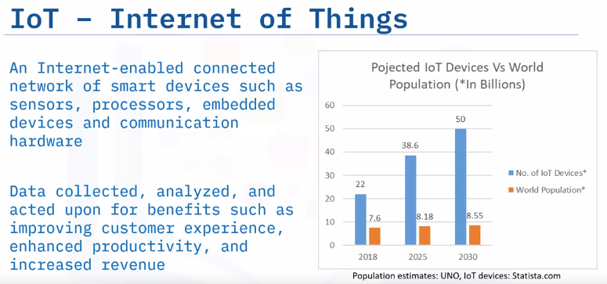

The Internet of Things (IoT) refers to a system of physical objects that are connected through the Internet. A “thing or device” can include a smart device in our homes, or a personal communication device such as a smartphone or computer. These collect and transfer massive amounts of data over the Internet without any manual intervention by using embedded technologies All of these devices gather, analyze, share, and transmit data in real time. Without Big Data, IoT devices would not hold the functionalities and capabilities which have gained them so much attention globally. Following Statista’s forecast, we will see four times more IoT devices than the total number of the entire world population by 2030.

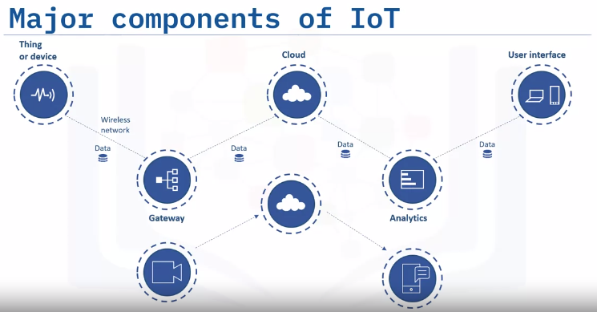

Let’s look at major components of the IoT ecosystem. An Internet-enabled connected network of systems, that comprise smart devices and sensors, constantly produce and transmit a variety of data. This Big Data is passed through a Gateway that routes it to its destined storage in the Cloud. Data Engineers use sophisticated algorithms to make sense of this collected Big Data and compile it into an analytical form that can be interpreted by humans. The analyzed data is then used to make business and consumer decisions to enhance the customer experience and to enhance productivity. For example, a security camera could continually upload footage, and a cloud-based big data algorithm may alert the user if any activity is detected.

**Summary:**

Big Data is everywhere and is being collected and used to drive business decisions and influence people’s lives. Virtual personal assistants like Siri on Apple devices, or Alexa on Amazon devices, use Big Data to devise answers to the infinite number of questions end-users may ask. Google Now impacts people through using Big Data to forecast future needs and behavior. Internet of Things (IoT) devices continually generate massive volumes of data; and Big Data analytics helps companies gain insights from the data collected by IoT devices.

# Parallel Processing Scaling and Data Parallelism:

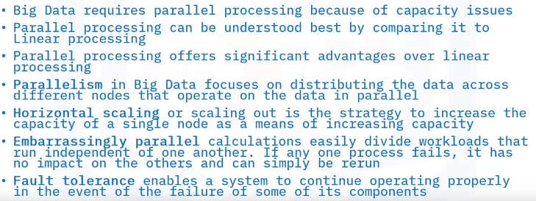

# Big Data Tools and Ecosystem:

Big Data tools have six different categories.

* Data Technologies
* Analytics and Visualization
* Business Intelligence
* Cloud service providers
* NoSQL Databases; and
* Programming Tools.

## Data Technologies:

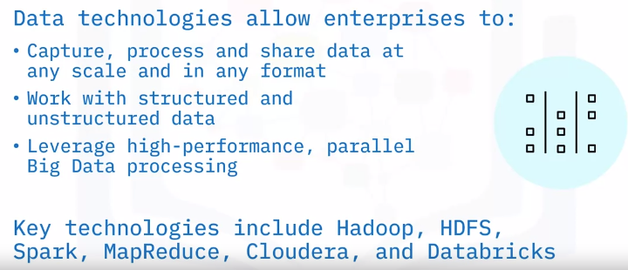

## Analytics and Visualization:

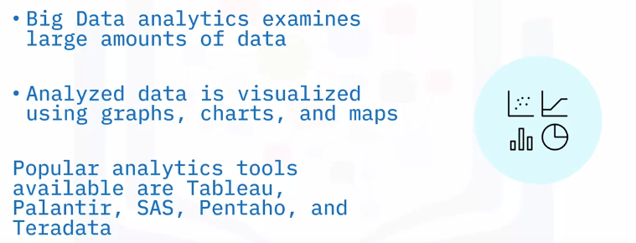

## Business Intelligence:

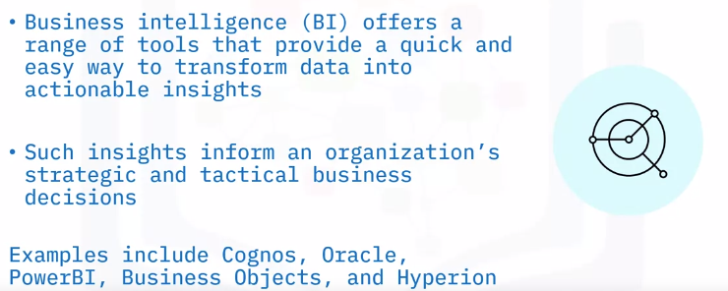

## Cloud Providers:

Big Data presents challenges to storing, transporting, processing, mining, and serving enormous amounts of data. Cloud providers offer fundamental infrastructure and support with shared computing resources including computing, storage, networking, and analytical software. Cloud providers also provide “software as a service” models with point solutions to allow enterprises to easily aggregate, process, and visualize data. Examples of Cloud service providers include AWS, IBM, GCP, and Oracle.

## NoSQL Databases:

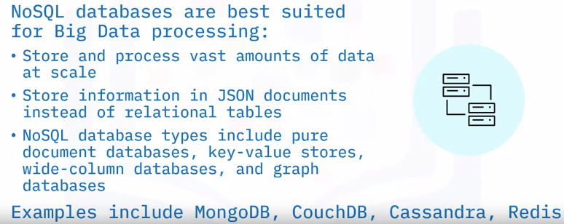

## Programming Tool:

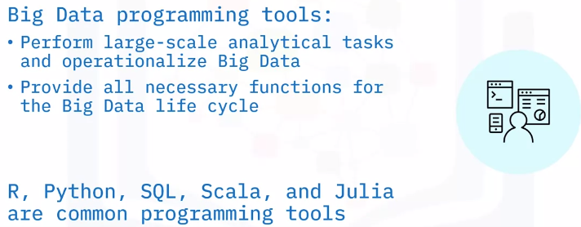

# Open Source and Big Data:

Most open-source projects have formal processes for contributing to code, and also include various levels of influence and obligation to the project. Committer, contributor, user, user group. Typically, committers have the ability to modify the code directly, while contributors submit their code for review (by a committer) before the code is modified. Many more people are simply users of the code.

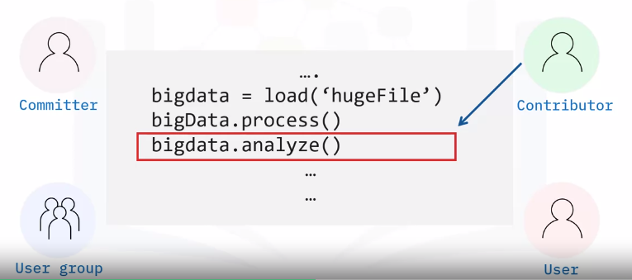

## Open Source Platforms:



## Open Source in Big Data:

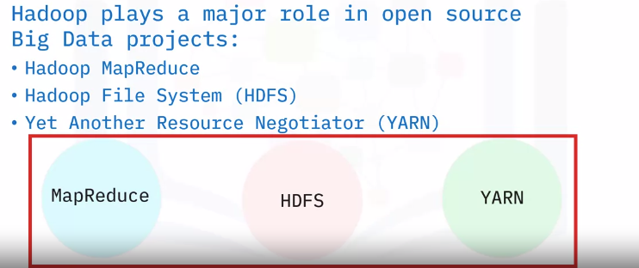

The biggest component of big data is, by far, the Hadoop project and its three main components: MapReduce, The Hadoop File System (HDFS), and The resource manager (YARN). MapReduce is a framework that allows code to be written to run at scale on a Hadoop cluster. It is still used, but not as much as more modern Big Data computation frameworks like Apache Spark. HDFS is the file system that stores and manages Big Data files. It manages all of the issues around large and distributed datasets, including resilience and partitioning. It is still a mainstay of the industry. 70% of the world’s Big Data resides on HDFS. More modern approaches to distributed storage, such as S3 and object storage, are coming into use, but they are based on the design principles of HDFS. YARN is the resource manager that comes with Hadoop, and it is the default resource manager for many Big Data applications, including HIVE and Spark. It is one of the most robust resource managers in use today, but more modern container-based resource managers (like Kubernetes) are slowly becoming the new de facto standards. Concluding, these are the main components of the Hadoop ecosystem, and most big data applications are built on top of them.

## Open Source tools in Big Data:

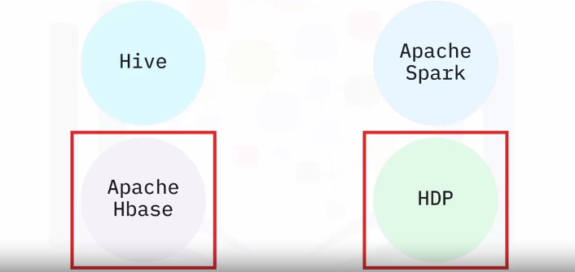

The array of big data applications available to the user is dizzying. They all build upon the basic Hadoop framework or interact with it in some way, however. Frameworks like Hive and Spark support lots of ETL (Extract, Transform, Load) and computation tasks on Hadoop systems. Some systems that integrate tightly with the Hadoop ecosystem are: Apache Hbase, which is a large NoSQL datastore. It manages storage and computation resources outside of the Hadoop ecosystem but often resides on the same cluster. Open-source packages like the Hortonworks Data Platform (HDP) provide a set of big data tools that are already configured to work together, and include most of the important open source packages (Hadoop, Spark, Hive, Hbase, and others).

**Summary:**

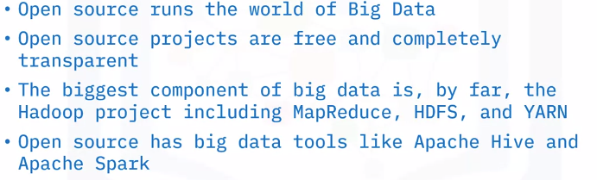

# The hype about Big Data:

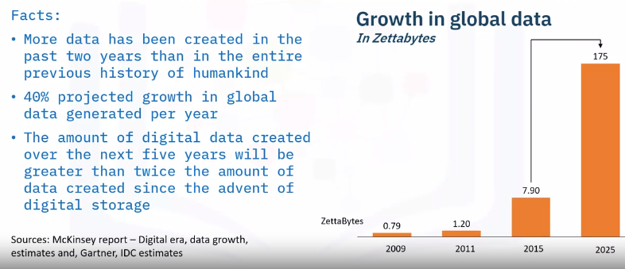

The chart on the right shows the growth in global data in zettabytes.

